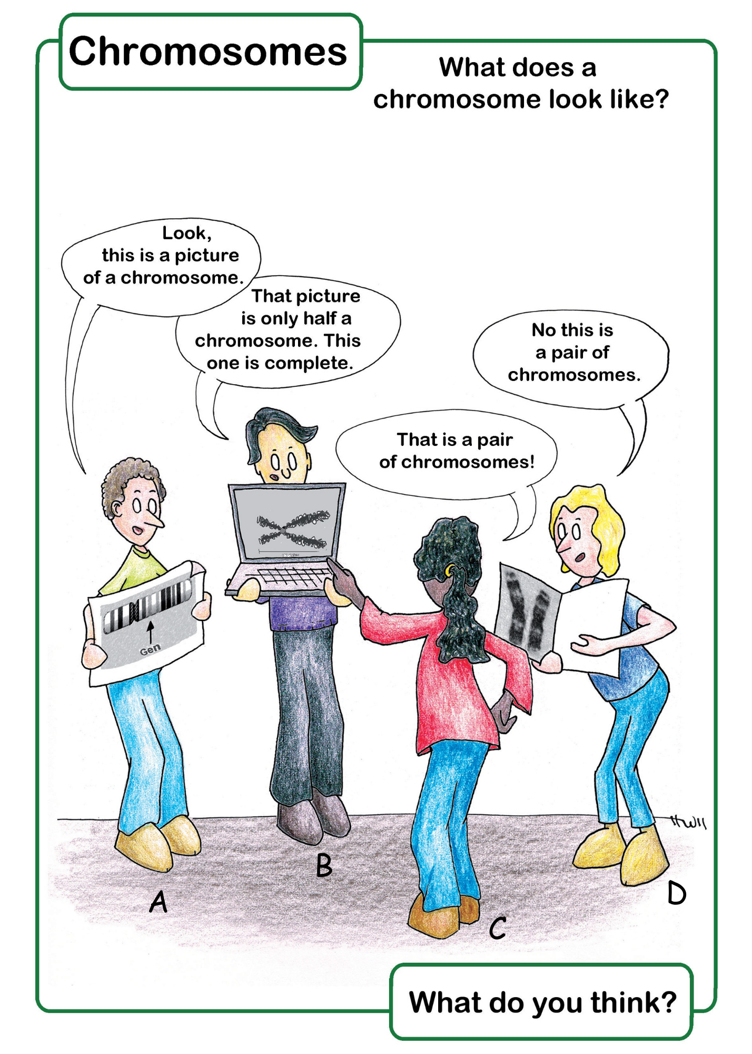

Teacher's guide - Concept cartoon: What does a chromosome look like?

Suggested teaching approach
Have students look at the cartoon and silently write down who they agree with and why. This ensures that everyone thinks for themselves and activates relevant prior knowledge. It prevents stronger students from immediately dominating the discussion.
Have students discuss and exchange ideas in small groups. Encourage them to question each other's reasoning. Avoid a judgmental attitude when students share their ideas. The uncertainty that Concept Cartoons evoke is precisely what makes them valuable for the learning process. Walk around so you can hear what conceptions students have.
If time permits: exchange different lines of reasoning as a whole class. Ask probing questions: Why do you think that...? What would happen if...?
Provide the correct answer and make explicit why only this is the correct answer, and why the others are incorrect. Ensure that students articulate, write down, or apply the correct reasoning so that no one accidentally leaves the lesson with a misconception.

Answer key for teacher
A: Correct, this is a schematic representation of a chromosome. The arrow indicates the location of a gene. In reality, each visible band contains tens to hundreds of genes.
B: Incorrect, it is one chromosome after replication (just before the start of mitosis) and contains two identical sister chromatids.
C: Incorrect, it is one chromosome after replication and contains two identical sister chromatids. It is therefore half of a homologous chromosome pair.
D: Correct, this is an edited microscopic photo of a homologous chromosome pair. The chromosomes are only visible under a light microscope when they are condensed (coiled up) and the preparation has been stained to make the bands visible. The chromosomes do not normally lie next to each other like this in the cell, but have been placed side by side using image editing software so you can see that it is a homologous pair (same banding pattern and size).

Source: Domis-Hoos, M., Kapteijn, M., & Boerwinkel, D. J. (2012). Genetica in beweging – de moeite waard om te leren. Utrecht: NVON.

